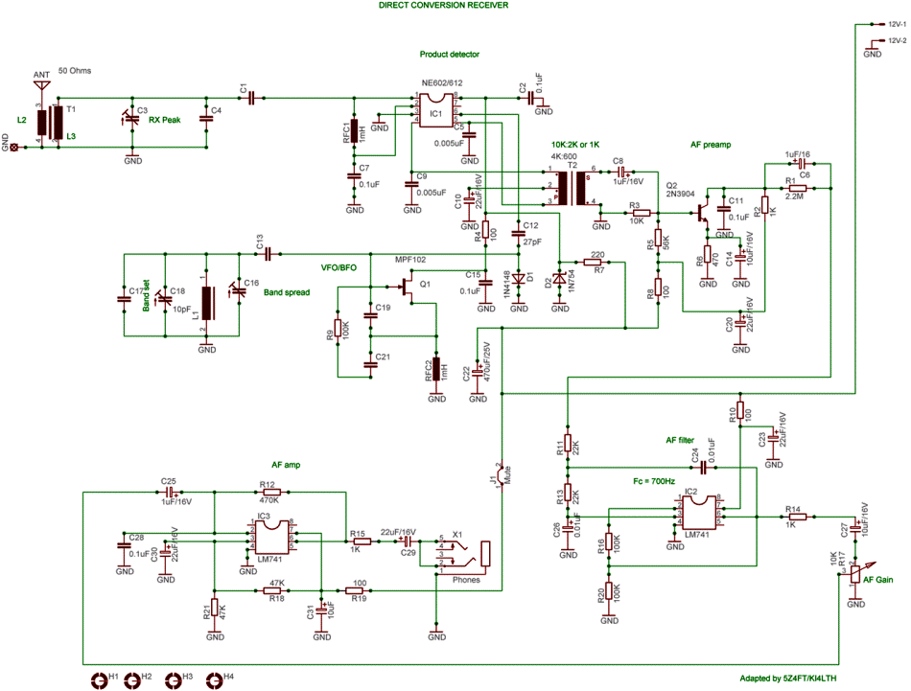
Description.
Direct Conversion receivers are the most popular QRP receivers for the reception of SSB or CW modes. The availability of IC's, improves their performance, and reduces parts count, making them simple to build, and easy to use. With a product detector, the input signal is mixed with a VFO signal close to the input signal, the result is an audible beat tone, which is processed. In this popular, and widely adopted DCRX an NE/SA602 is used as the product detector. The resulting audio is filtered, and then amplified to a comfortable level for headphone use. In this design from W1FB, Q1, which could be a MPF102 or 2N4416, is the VBFO, Q2 provides audio pre-amp, IC2 audio band pass filtering with a center of 700Hz, IC3 gives audio gain for headphones. Jumper J1 should be removed to provide muting for transmit periods. This can be done using a relay or external PNP switch. The receiver can run from a 9V, or 12V DC source. This design can be improved by adding a RF gain control, substituting the SA/NE602 with a SA/NE612, improving the audio amplification, and filtering, adding a digital frequency readout, a RF filter with sharper roll-out, and using varicap tuning rather than air-variable tuning(C16 is an air-variable, while C18, and C3 can be trimmers. C3 should be an air-variable at 80M) This particular design has a low parts count, and can be reproduced on a breadboard, or perf-board. Note that the audio isolation transformer may be hard to find, but can be substituted with an audio interstage transformer with a 10K Primary, and 2K Secondary. Far Circuits makes a PCB(Universal Direct Conversion Receiver) board for this design.
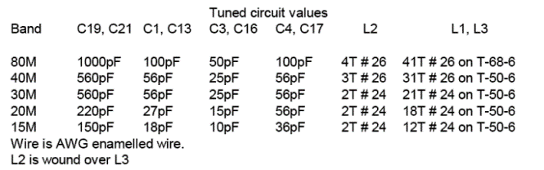

Modified implemenation of above Direct Conversion RX.
Below is the schematic and Eagle(CADSOFT) board(2.25" x 1.95") file of a modified implementation of the above DCRX!
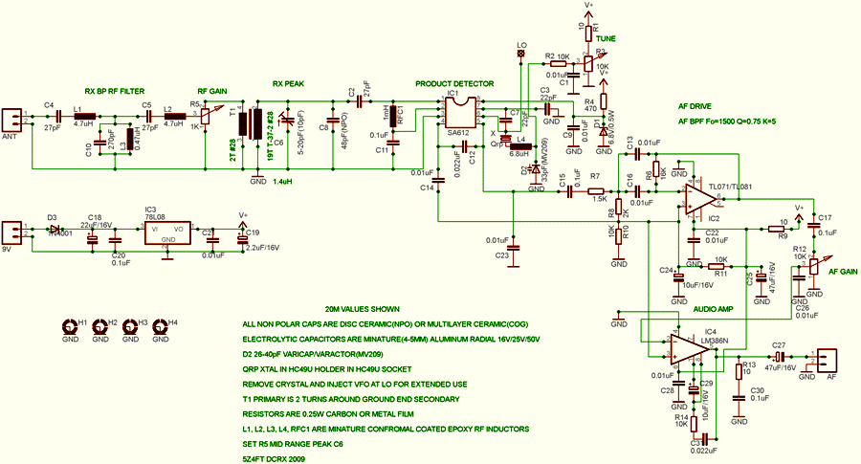

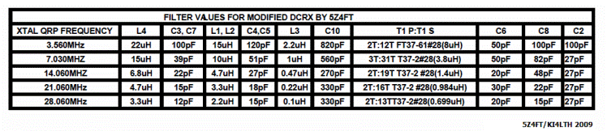
5Z4FT DCRX Board File

